Craighead Road 774 Closed

RELEASE DATE: September 19, 2024

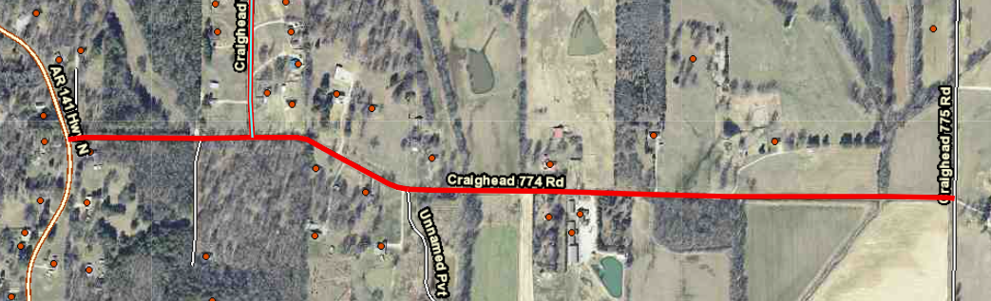

The Craighead County Road Department will close County Road 774 between Hwy 141 and County Road 775.

We are beginning Tuesday, September 24, 2024, for approximately four (4) weeks. At this time, a bridge will be replaced.

Detour signs will be posted to alert the public, and motorists will be asked to use caution in the area.

Commuters should allow for additional travel time.